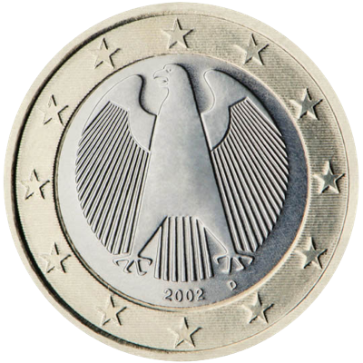

**You**

**Sorry, you lose this round**

**Computer**